PRACTICLE 4
Name : Ranudi Gayathmie Kariyapperuma
Index : 29897
Batch No : 23.1
Degree Program Name : Technology Management

Q1) #include<stdio.h>
int main()
{
int no,ans;
printf("Enter number : ");
scanf("%d",&no);

ans=no%2;

if (ans==0)
printf("%d is an even number\n",no);
else
printf("%d is an odd number\n",no);
return 0;
}

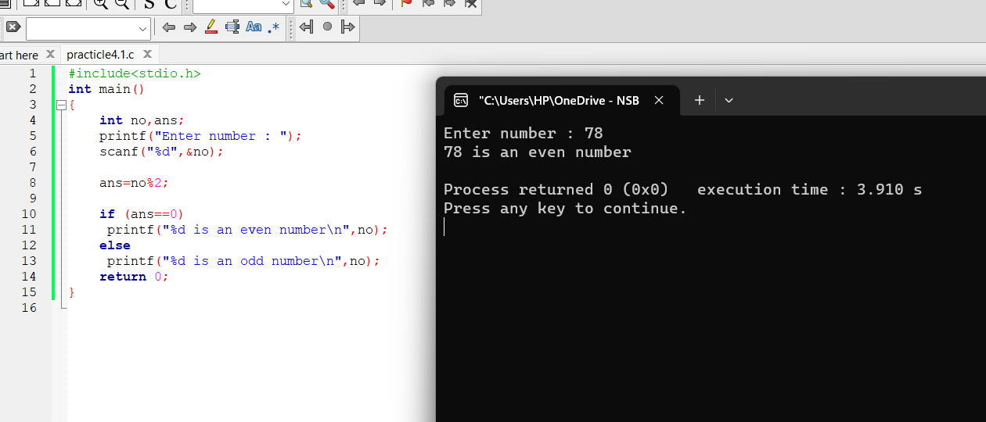
Switch statement

#include<stdio.h>
int main()
{
int no,ans;
printf("Enter number : ");
scanf("%d",&no);

switch(no%2)
{
case 0 :printf("%d is an even number\n",no);break;
case 1 :printf("%d is an odd number\n",no);break;

}

}

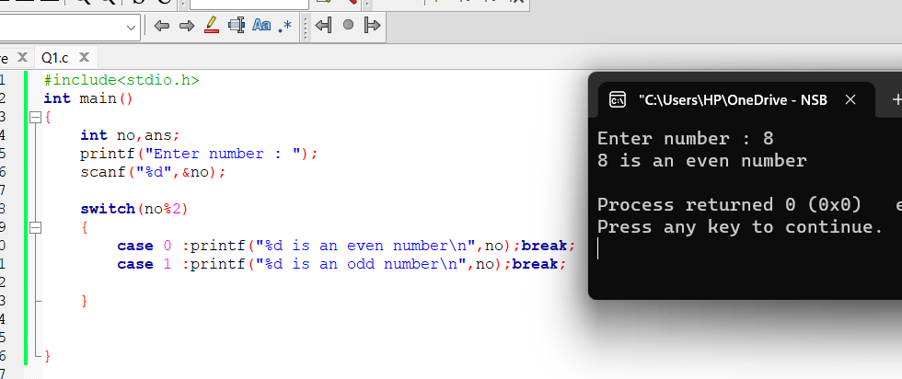

Q2)
#include <stdio.h>
int main()
{
int no1,no2,choice;
printf("Enter two numbers: ");
scanf("%d%d",&no1,&no2);

printf("1. + \n");
printf("2. - \n");
printf("3. * \n");
printf("4. / \n");

printf("\nPlease enter your choice: ");
scanf("%d",&choice);

switch(choice)
{
case 1:printf("\n%d\n",no1+no2);break;
case 2:printf("\n%d\n",no1-no2);break;
case 3:printf("\n%d\n",no1*no2);break;
case 4:printf("\n%d\n",no1/no2);break;
}
return 0;
}

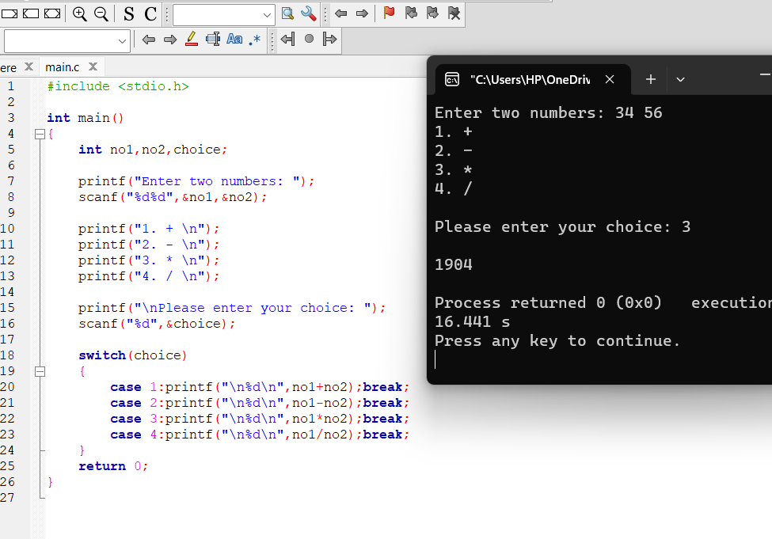
Q3)

#include <stdio.h>
int main()
{
int choice;
float radius, PI=3.14159;

printf("1. Calculate the circumference of a circle\n");
printf("2. Calculate the area of a circle\n");
printf("3. Calculate the volume of a sphere\n");
printf("\nEnter your choice (1-3): ");
scanf("%d", &choice);

printf("Enter the radius: ");
scanf("%f", &radius);

float circumference = 2 * PI * radius;
float area = PI * pow(radius, 2);
float volume = (4.0 / 3.0) * PI * pow(radius, 3);

switch (choice)
{
case 1:printf("The circumference of the circle is: %.2f\n",
circumference);break;
case 2:printf("The area of the circle is: %.2f\n", area);break;
case 3:printf("The volume of the sphere is: %.2f\n",
volume);break;
default:printf("Invalid choice!\n");break;
}

return 0;
}

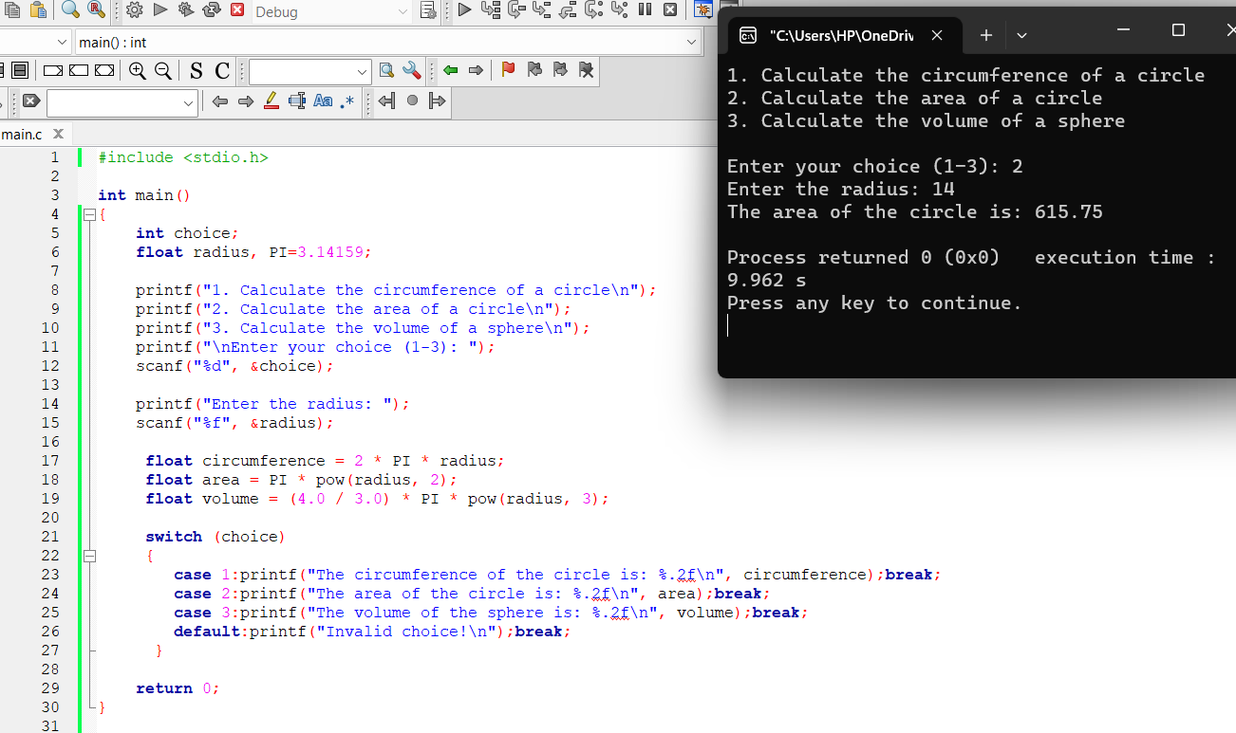

Q4)

#include <stdio.h>
int main()
{
char ch;
printf("Enter a character: ");
scanf("%c",&ch);

switch(ch)
{
case'a':printf("a is a vowel\n");break;
case'e':printf("e is a vowel\n");break;
case'i':printf("i is a vowel\n");break;
case'o':printf("o is a vowel\n");break;
case'u':printf("u is a vowel\n");break;

default:printf("%c is not a vowel\n",ch);
}
return 0;
}

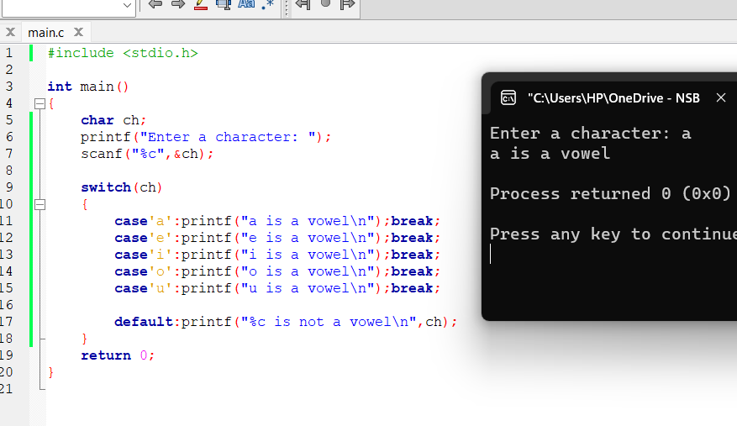

Q5) #include <stdio.h>
int main()
{
int m;
printf("Enter a month number: ");
scanf("%d",&m);

switch(m)
{
case 1 :printf("January\n");break;
case 2 :printf("February\n");break;
case 3 :printf("March\n");break;
case 4 :printf("April\n");break;
case 5 :printf("May\n");break;
case 6 :printf("June\n");break;
case 7 :printf("July\n");break;
case 8 :printf("August\n");break;
case 9 :printf("September\n");break;
case 10:printf("October\n");break;
case 11:printf("November\n");break;
case 12:printf("December\n");break;

default:printf("%d is not a valid month number\n",m);
}
return 0;
}

